TOPIC: AUTOMATIC SMOKING ZONE MONITORING EXHAUST FAN ON

No smoking zones are meant to ensure smoke free areas which promote good health and being well. Especially in public places and our home no smoking zones ensure smoke free environment for people and children. But it is not feasible to manually monitor these zones to ensure a smoke free environment and an automated system is required to ensure this. Here we propose a fully automated smoking zone alerting monitoring system to sound an alarm in case a smoker is detected and automatically the exhaust fan activated in order to removing unwanted smoke and pollutants in a smoking zone. The system uses a combination of smoke sensing, exhaust fan with Arduino circuitry to ensure this purpose.

**PROBLEM SOLVED BY THIS SYSTEM**

* Ensure good health even if there some one smoking due to exhaust fan removing immediately smoke detected.
* An exhaust fan can be placed in a room of children in case there is someone try to smoking in any room of house as long as you are not there to stop him they will have no problem.
* It will also prevent the problems of respiratory diseases.

**A LIST OF ALL REQUIRED COMPONENTS ARE:**

1. Smoke sensor -> which detects the level of smoke

2. Arduino UNO - > A microcontroller board based on the ATmwg328p

3. Buzzer -> A device produce sound or alarm

4. Resistors -> to resist the current

5. PCB and Breadboards

6. 5V LED -> emitting diode that emits light

7. Jumper wires -> for connecting the elements of the circuit

8. Relay -> open and close the circuits by receiving electrical signals from outside sources

9. 9v battery supply -> produce electricity, positive and negative charges

10. Liquid crystal display (16×2 LCD) -> display 16 characters per line and there are 2 such lines.

11.Exhaust fan -> to remove unwanted smoke in the air

**IMAGE OF COMPONENT**

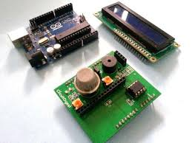

### [How to make Smoke Detection Alarm using Arduino?](https://www.geeksforgeeks.org/how-to-make-smoke-detection-alarm-using-arduino/)

[**More results**](https://www.google.com/search?client=ms-android-transsion-infinix-rev1&sxsrf=AJOqlzWWyKNx9xUVo0Q7ZcZe9XdTefmTmA:1677761783550&q=How+to+make+smoke+detector+alarm+using+Arduino%3F&sa=X&ved=2ahUKEwi954DZpb39AhURkokEHfaqAjIQzmd6BAhsEAY)

How to make smoke detector alarm?

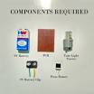

First remove the case of fluorescent light starter and then remove the capacitor form it. Connect positive terminal of the battery to the positive terminal of piezo buzzer. Negative pin of piezo buzzer goes to any one of the pin of tube light starter. Another pin of Starter goes to negative pin of the battery.

### [How To Create a Fire Detection Alarm System Using Arduino UNO ...](https://www.c-sharpcorner.com/article/how-to-create-a-fire-detection-alarming-system-using-arduino-uno-r3/)

[**More results**](https://www.google.com/search?client=ms-android-transsion-infinix-rev1&sxsrf=AJOqlzWWyKNx9xUVo0Q7ZcZe9XdTefmTmA:1677761783550&q=How+do+I+make+a+fire+detection+alarm+with+Arduino+Uno%3F&sa=X&ved=2ahUKEwi954DZpb39AhURkokEHfaqAjIQzmd6BAhmEAY)

What is smoke level detector?

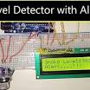

Smoke Detector Circuit which **not only senses the smoke in the air but also reads and displays the level of Smoke in the Air**. This circuit triggers the Buzzer when Smoke level becomes higher than the desirable limit, this threshold value can be changed in the Code according to the requirement.

**SAMPLE CONNECTION OF ALL COMPONENTS**

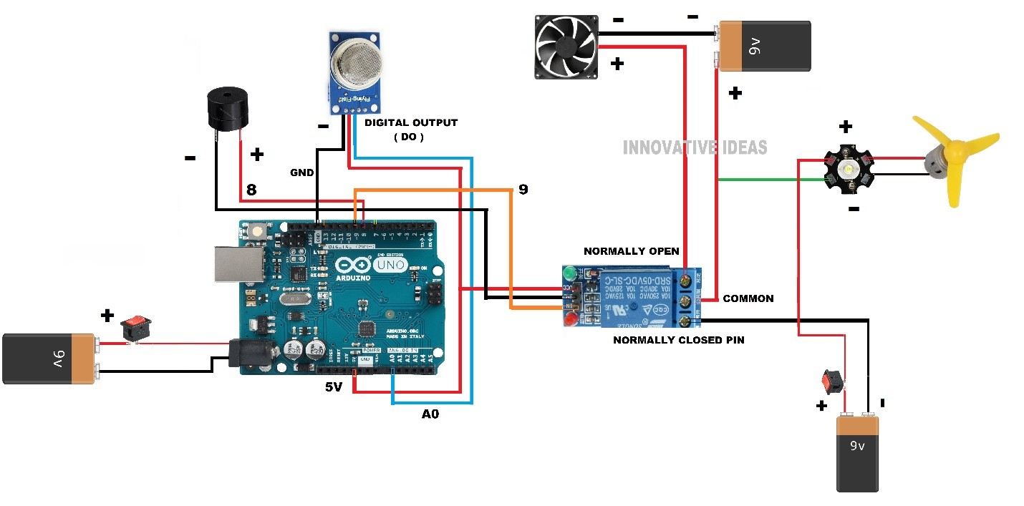

**BLOCK DIAGRAM**

Exhaust fan

Relay

Buzzer

Arduino

UNO

SMOKE SENSOR

In this Smoke Detector Bock diagram with Arduino, we have used a MQ2 Gas Sensor to detect preset smoke in the air. A 16x2 LCD is used for displaying the PPM value of Smoke. And an LM358 IC for converting smoke sensor output into digital form

**FRTIZING DIAGRAM**

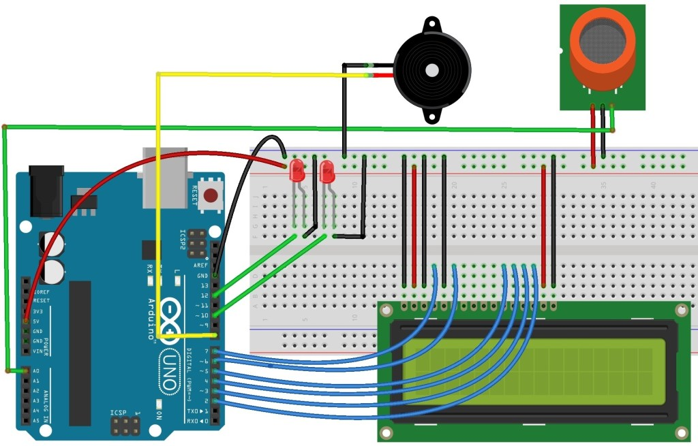

**Arduino source Code:**

/*

Code started

#include <LiquidCrystal.h>

LiquidCrystal lcd (12,11,5,4,3,2);

int relay =6;

int redLed =10;

int greenLed =9;

int buzzer =8;

int smoke =A0;

int sensorThes =100;

void setup (){

pinMode(relay,OUTPUT);

pinMode(redLed,OUTPUT);

pinMode(greenLed,OUTPUT);

pinMode(buzzer,OUTPUT);

pinMode(smoke,INPUT);

Serial.begin(9600);

lcd.begin(16,2);

}

void loop (){

int analogsensor = analogRead (smoke);

Serial.print("pin A0:");

Serial.println(analogsensor);

lcd.print(analogsensor-50);

if (analogsensor-50 > sensorThes )

{

digitalWrite(relay,HIGH);

digitalWrite(redLed,HIGH);

lcd.setCursor(0,2);

lcd.print("…….smoking.....!!!");

digitalWrite(greenLed,LOW);

tone(buzzer,1000,200);

}

else

{

digitalWrite(relay,LOW);

digitalWrite(redLed,LOW);

digitalWrite(greenLed,HIGH);

lcd.setCursor(0,2);

lcd.print("......NORMAL......");

noTone(buzzer);

}

delay(500);

lcd.clear ();

}